**Report 2**

Members: Floyd R, Fei Xu, Minh Truong

The landscape and noise map we are going to combine are:

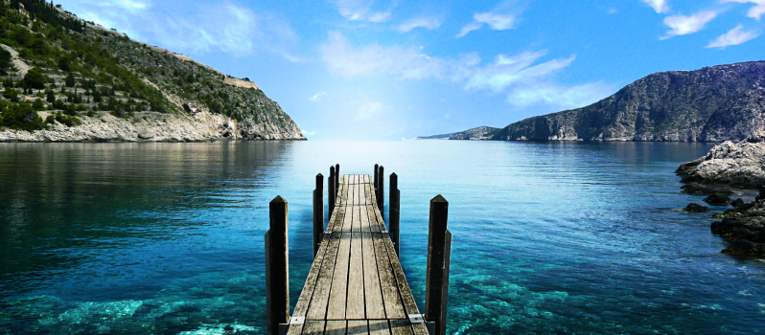 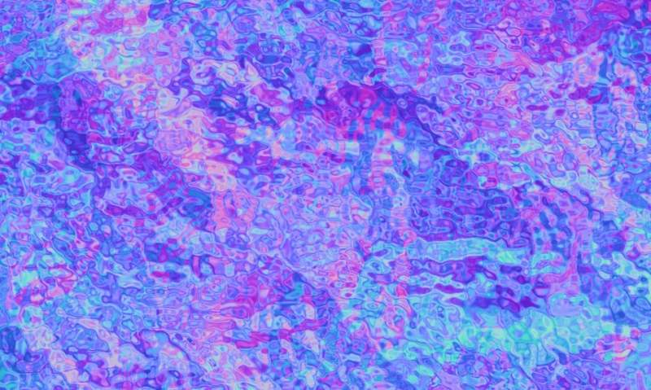

landscape noise map

We use every pixel on the noise map as a vector displacement. We use the color information of noise map as vector displacement as following the rule:

Red from (0-255) receives X (-1.0, 1.0)

Green from (0-255) receives X (-1.0, 1.0)

Blue from (0-255) receives X (0.0, 1.0).

We use

noisevec = normalize(texture(texture_foreground, pass_TexCoord).xy)

to generate the displacement vector and scale it by

noisevec = (noisevec * 2.0 - 1.0 ) * 0.02,

since the coordinates of texture is in (0,1). By (noisevec * 2.0 - 1.0 ) it is scaled into (-1,1). Then we use a factor to control how large the displacement is.

So if we scale it as “noisevec = (noisevec * 2.0 - 1.0 ) * 0.02”, the result is:

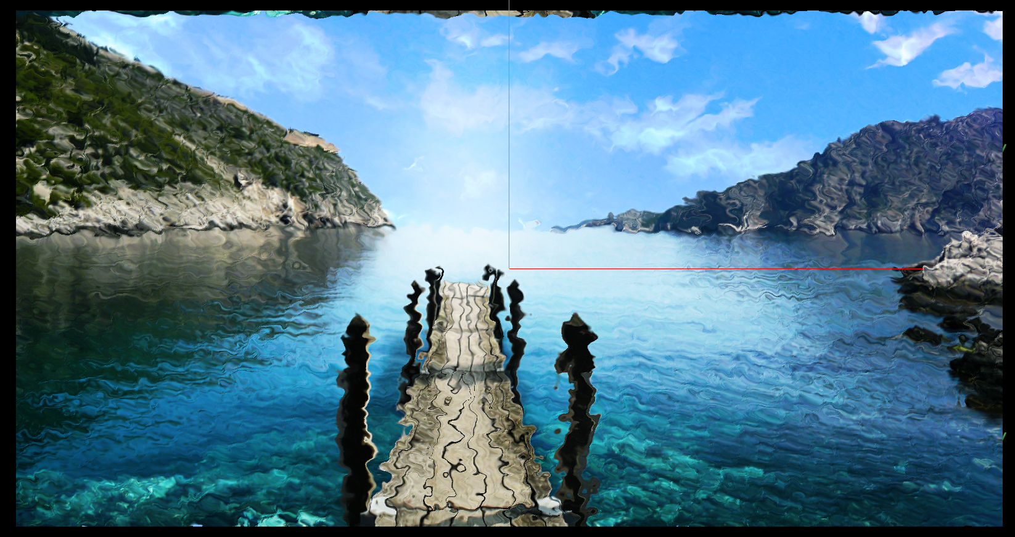

If we scale it as “noisevec = (noisevec * 2.0 - 1.0 ) * 0.2”, the result is:

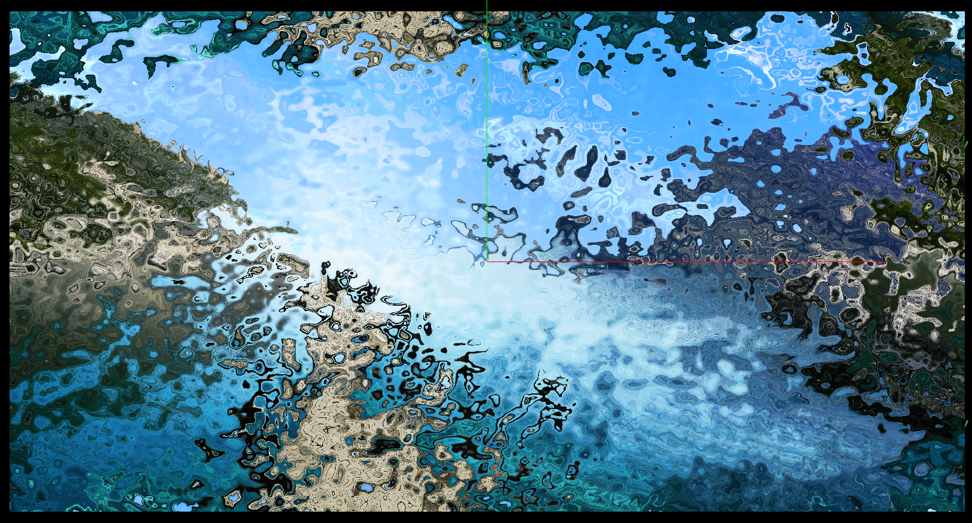

The larger value we use to scale the noisevec, the larger the displacement we give the coordinates of the texture, distorting the image.

This seems to be an effective way to model reflections off of water, or light seen through water.